Patient Referral Form
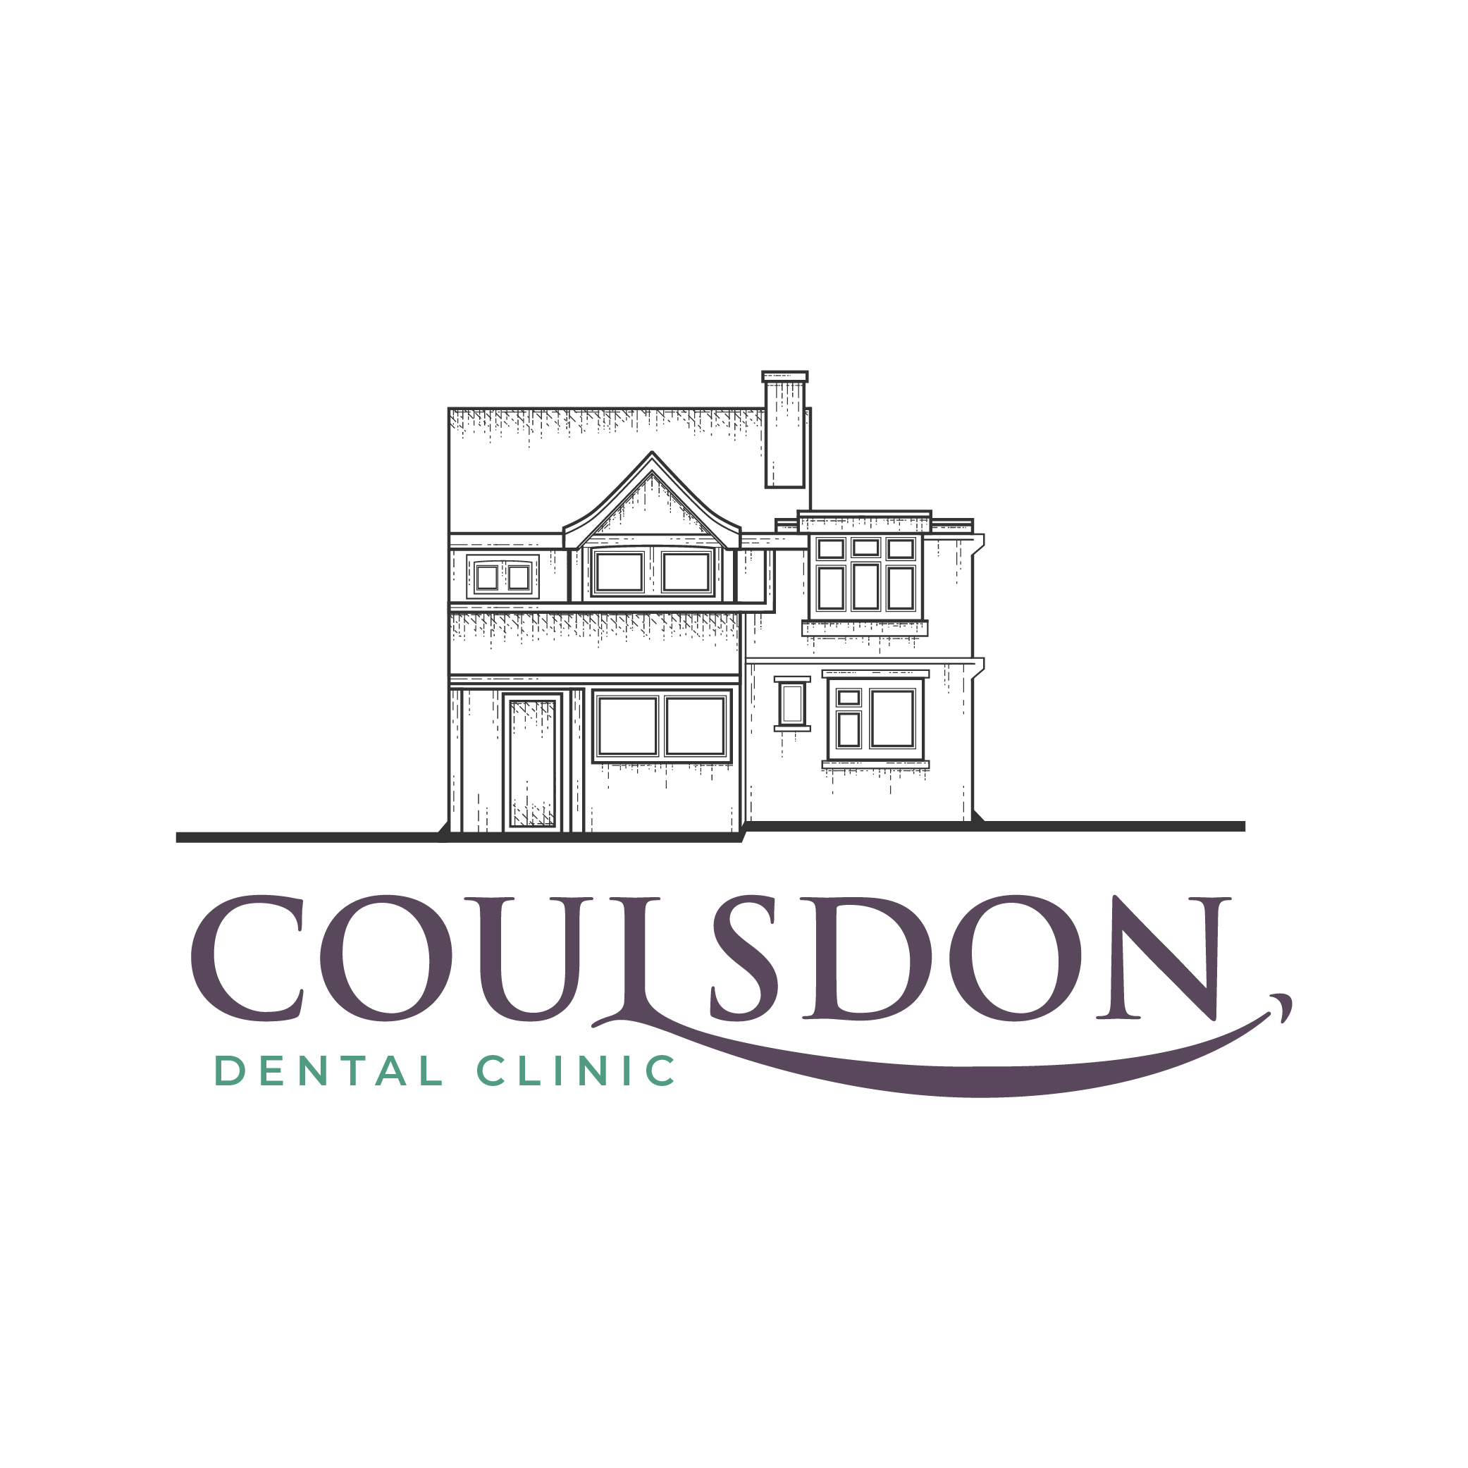
Coulsdon Dental Clinic
72 Brighton Road, Coulsdon
Surrey, CR5 2BB
T: 0208 660 3308
E: contact@coulsdondentalclinic.co.uk
W: www.coulsdondentalclinic.co.uk

SPECIALIST ENDODONTICS

Dr Ahmed Ali BDS (Hons), MSc.(Clin) Endodontics, MEndo RCS Ed

Patient Details
Title
First Name
Surname
DOB
Tel (Home)
Tel (Mobile
Address
Email

Reason for Referral
Primary RCT

Re-treatment/Apicectomy

Please tick any that apply

Pulp exposure
Trauma
Radiolucency
Vague symptoms
Suspect crack
Previously attempted
Previous root treatment
Call me for special instructions

1 2 3 4 5 6 7 8
8 7 6 5 4 3 2 1

1 2 3 4 5 6 7 8
8 7 6 5 4 3 2 1

Comments:

Referring Practitioner
Dentist Name
Practice Name
Practice Address
Date
Tel
We will contact patients directly to make an appointment. Many thanks for your Referral.

