Patient Referral Form
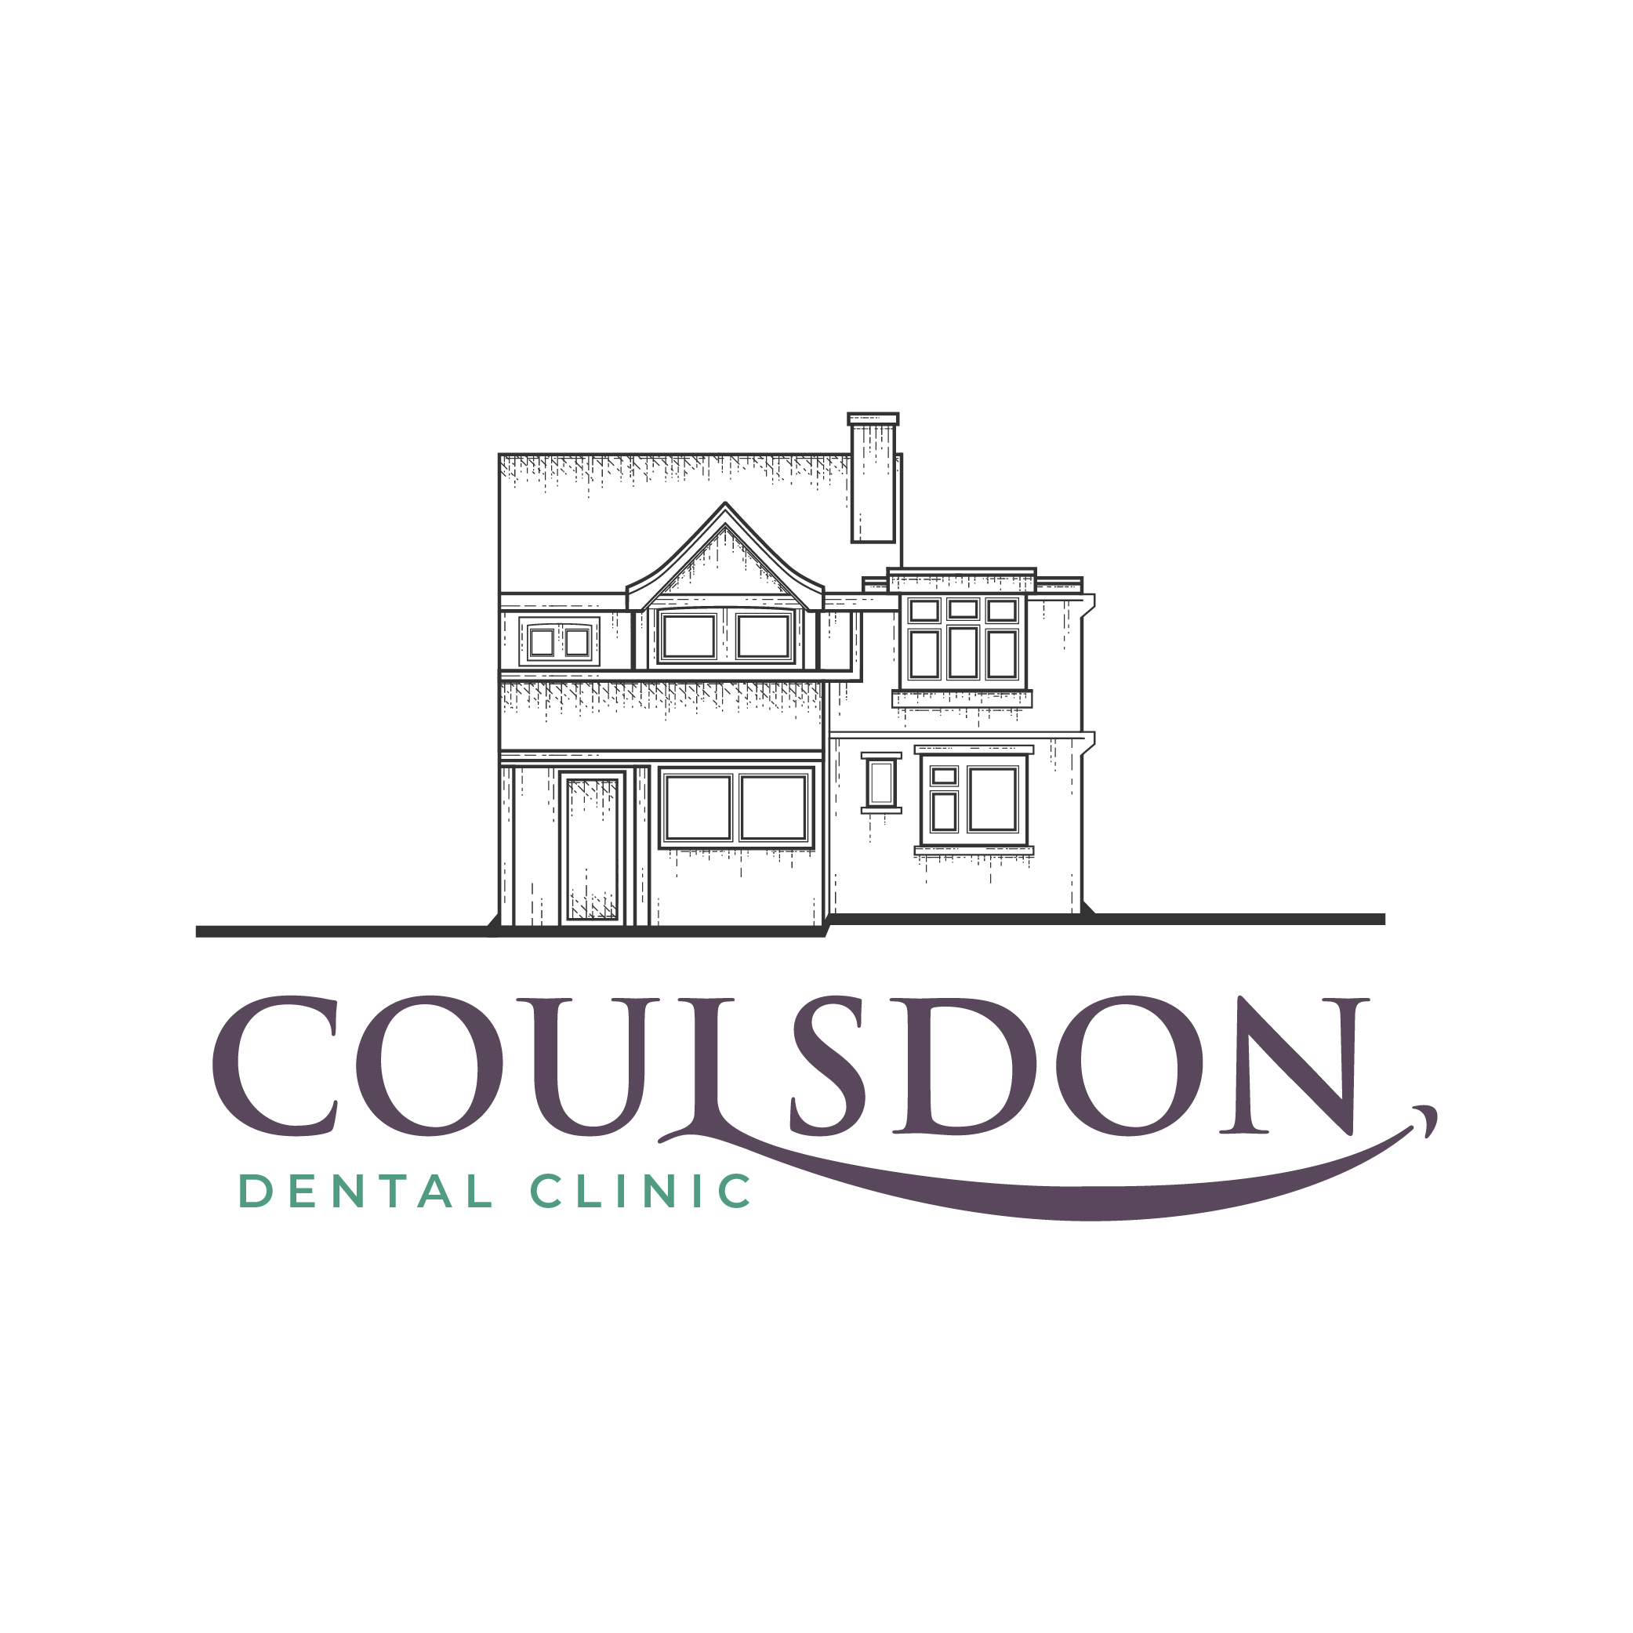
Coulsdon Dental Clinic
72 Brighton Road, Coulsdon
Surrey, CR5 2BB
T: 0208 660 3308
E: contact@coulsdondentalclinic.co.uk
W: www.coulsdondentalclinic.co.uk

Implant Surgeon

To make a referral for dental implants, please complete the form below and save it to your computer before attaching it and sending it Coulsdon Dental Clinic.

If you have difficulty completing this form, please enter data manually and then print and post a completed form to Coulsdon Dental Clinic, 72 Brighton Road, Coulsdon, CR5 2BB

Patient Details

Title
First Name
Surname
DOB
Tel (Home)
Tel (Mobile
Address
Email

Referring Details

L
R

k
8
7
6
5
4
3
2
1
1
2
3
4
5
6
7
8
6
8
7
5
4
3
2
1
1
2
3
4
5
6
7
8

Presenting Complaint and History

Does the tooth/teeth require extracting?

Other options discussed?

Last Dental Exam?

Referring Dentist Details

Dentist Name
GDC Number
Practice Address
Postcode
Referral Date
Mobile
Email

Your patient will complete a Medical History Form at their consultation appointment.

Please advise your patient the consultation fee is
£80.00

