Patient Referral Form
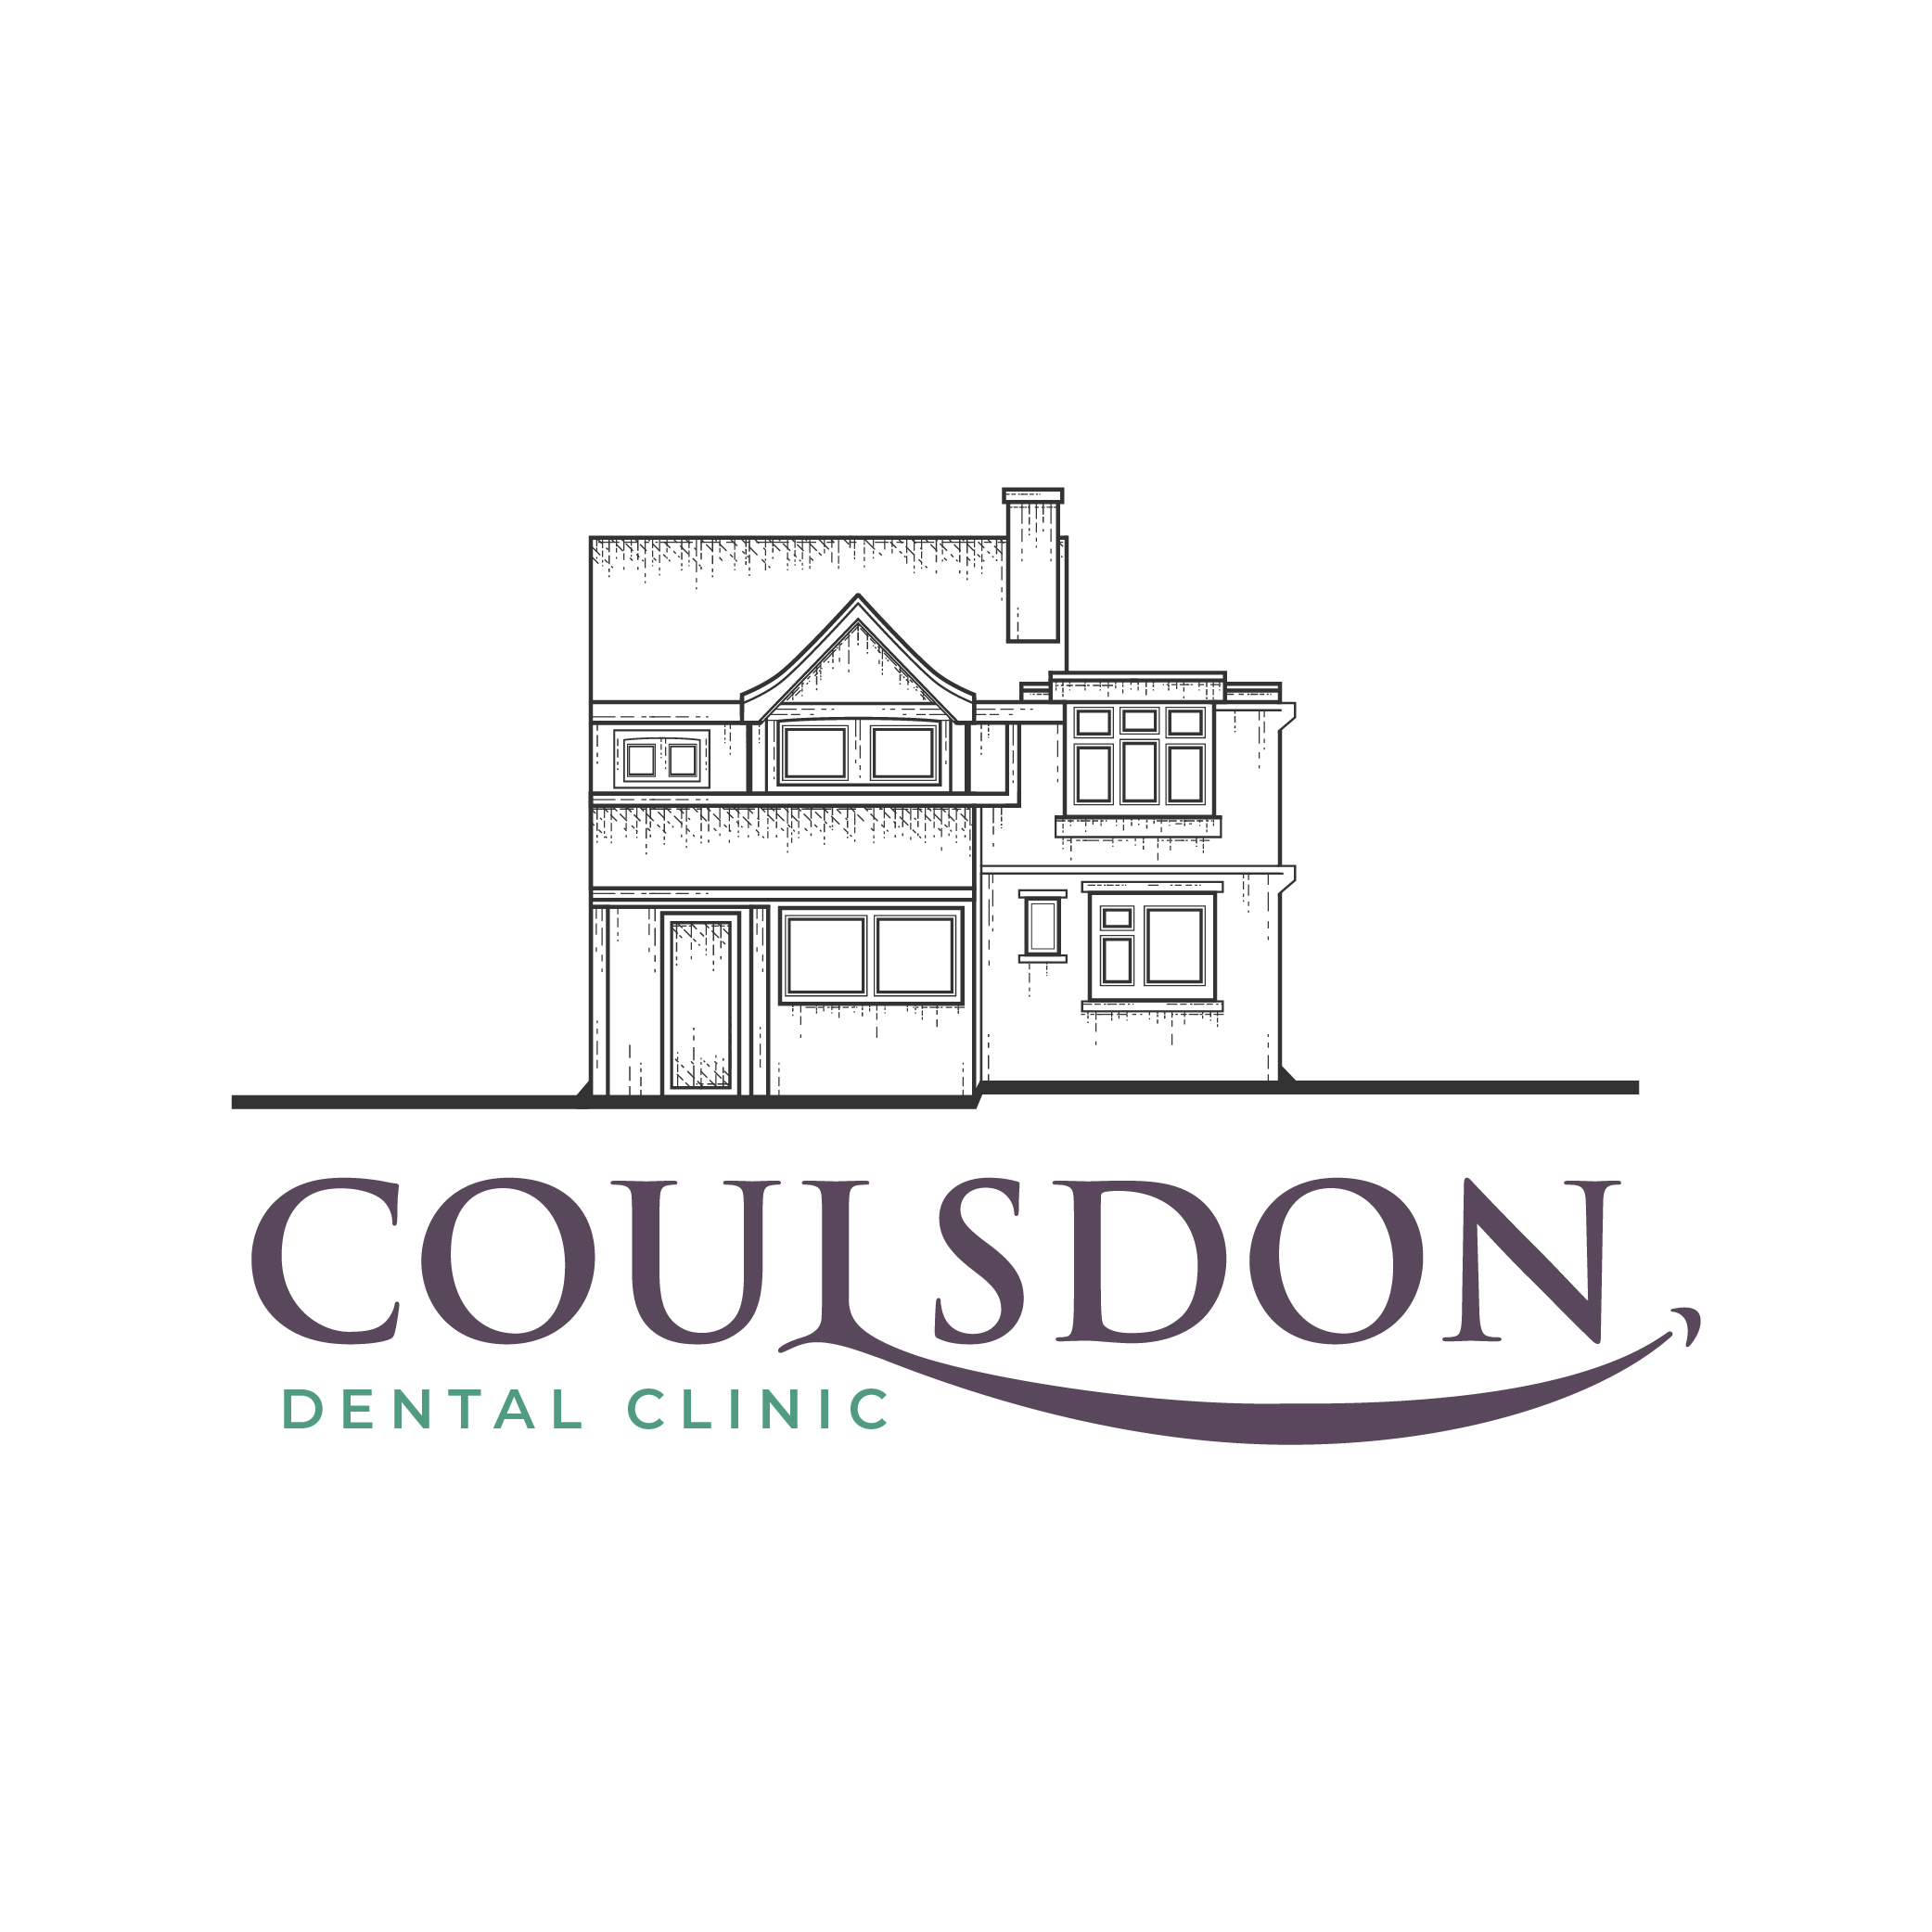
Coulsdon Dental Clinic
72 Brighton Road, Coulsdon
Surrey, CR5 2BB
T: 0208 660 3308
E: contact@coulsdondentalclinic.co.uk
W: www.coulsdondentalclinic.co.uk

SPECIALIST ORAL SURGEON

Dr Mohammed Dungarwalla BDS(Hons) MFDS RCS(Ed) MSc PGCert(MedEd PGCert(ClinRes) MOralSurg(RCSEd)

Patient Details
Title
First Name
Surname
DOB
Tel (Home)
Tel (Mobile
Address
Email

Reason for Referral
Consultation Required

Direct to Treatment

Please tick any that apply

Consultation
CBCT Scan
Routine Extraction
Surgical Extraction
Wisdom Tooth Extraction
Coronectomy
Exposure and Bond
Biopsy (Including report)
Fraenectomy
1 2 3 4 5 6 7 8
8 7 6 5 4 3 2 1

1 2 3 4 5 6 7 8
8 7 6 5 4 3 2 1

Comments:

Clinical Details of Patient
Condition being referred
Does Patient take Anticoagulants
Does Patient take Bisphosphonates
Has patient received radiotherapy to the head and neck region
Allergies
Preference for LA or Sedation
Any other information

Referring Practitioner
Dentist Name
Practice Name
Practice Address
Date
Tel

We will contact patients directly to make an appointment. Many thanks for your Referral.

